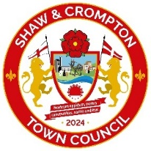
Shaw & Crompton Town Council

Annual Classic Car Show – Sunday 9 June 2024

Entry Form
Make & Model
of Vehicle

Registration  Number |  | Year

Class | A B C D E F G H  Indicate/circle one Category (see list)

Name
Address
Tel
Email

Please tick this box if you want to enter this year’s show

Please tick this box if you want to be invited to future shows
Please return to: Shaw & Crompton Town Council
1 Kershaw Street East
Shaw
Oldham
OL2 8AB

Email: clerk.shawcrompc@btconnect.com

Tel: 01706 847590 / Mob: 07436 229083

